**Food Estate: Problem Solving or Destruction? Netnography Approaches Using Network Analysis Through Youtube Channel**

**BBC News Indonesia**

Medi Trilaksono Dwi Abadi

Program Studi Hubungan Masyarakat, Universitas Pembangunan Nasional Yogyakarta

**Abstract**

*The research aims to determine the response of the community, especially the online community (netizens), regarding the implementation of the Food Estate program in Gunung Mas, Central Kalimantan. The Food Estate in Gunung Mas is programmed to plant cassava plants in peatland areas. The Food Estate Program is a food barn development program as an effort to maintain food security from the government. The term Food Estate program is a new form of development of the food barn program that existed in 1970, namely Rice Estate with a focus on planting rice plants to meet rice needs. The food barn construction program has always been considered a failure since 1970 until now with the new term Food Estate. This research uses social network analysis methods and text analysis on video coverage of Food Estate news in Gunung Mas on the BBC News Indonesia YouTube channel with the unique video code Zv_6jPUDAM4&t=63s. The results of the research show that community members around the food estate location in Gunung Mas stated that the food estate program was a failure because it actually caused various environmental problems, such as: cassava harvests not meeting targets tended to produce little fruit, efforts to convert forest land into what was planned to be a cassava harvest area actually caused environmental damage.*

*Keyword: food estate, netnography, toxicity analysis, BBC News Indonesia, communalytic*

**Introduction**

Food estate is one of the development programs related to food security (Rasman et al., 2023) which is included in the National Strategic Program in Indonesia for the 2020-2024 Period (Hamdiah et al., 2023). Food estate is the government's effort to prevent and overcome food availability problems. Indonesia is one of the countries in the form of an archipelago and has a large population with one of the main foodstuffs being rice. The agricultural sector contributes highly to improving the economy and meeting the food needs of the people in Indonesia (Ayun et al., 2020). Food estate is the use of large-capacity agricultural land that aims to produce or produce foodstuffs, especially for community members living in the area where the food estate is located (Rasman et al., 2023).

The development of food estates in Indonesia is a hope for the government in facing the challenge of meeting food needs in the future. The development of food estates is able to contribute positively in the form of labor absorption in the agricultural sector which has an impact on reducing poverty in Indonesia. Indonesia's economic improvement is more successful relying on agriculture than the manufacturing or construction sectors (Rani et al., n.d.). Food estate can also be interpreted as a Food Barn referring to the Regulation of the Minister of Environment and Forestry No. 7 of 2021 (Rizkia Diffa Yuliantika et al., 2022). Food estate or food barns is a national strategic program because the state is obliged to ensure food security for its citizens in accordance with the mandate of Law No. 8 of 2012 concerning Food which states that food security is a situation of food sufficiency for the country to meet individual needs which is characterized by the availability of adequate food in quantity and quality, safe for consumption, varied, contains high nutrients, spreads evenly, and reaches those that are not contrary to the religious values, beliefs and culture of the community in order to realize a healthy, productive and sustainable life (Rizkia Diffa Yuliantika et al., 2022).

Optimization of the food estate program will be better managed and achieved if it follows the classification standards determined by the Food Agricultural Organization (FAO), which is an organization for food and agricultural governance in the international scope established by the United Nations (UN) or United Nation (UN) (Hamdiah et al., 2023). In an effort to make the food estate program a success, Indonesia involves elements of the military, namely the Indonesian National Army (TNI) to act as facilitators, motivators, innovators, and dynamists who are trained with knowledge insights related to nursing, planting, fertilizing, and tactical insights to overcome various problems that arise in efforts to develop food estates (Hamdiah et al., 2023).

Youtube is a digital platform for various content in the form of interactive videos that trigger viewers to be able to respond in the form of likes (Likes/thumbs up icons), provide comments through long texts, subscribe to channels (Subscribe), and also provide replies to other viewers using the Reply Comment feature (Shajari et al., n.d.). The various comments that appear on each uploaded video vary, can cause a lot of comments up to tens of thousands of comments, it can be few, it can even not get any comments at all from other Youtube users who just want to watch the uploaded video. The quality of the image, audio, storyline structure, and message substance are the main things that affect the subconscious of Youtube users to decide whether or not to give their comments to account owners who upload certain themed video content.

Comments that appear from various Youtube user accounts can be analyzed to see how Youtube user accounts are connected to each other who comment on an uploaded video so that a network clustering (sociogram) will appear which has a great influence as a stimulus for the emergence of various follow-up comments with positive and negative nuances (*Social Network Analysis of YouTube Comment Replies: Bots or Disillusioned Citizens? – Nodus Labs Support Center*, n.d.). Analysis of comments on the Youtube platform is also used to understand the level of interest of other Youtube users in a particular topic or theme presented in the uploaded video content (Thelwall, n.d.). The advantage of the Youtube platform is that it is able to encourage Indonesian people through cyber networks to actively participate in commenting, especially on content that discusses various government policies as a form of concern and carries out a supervisory function over government performance (Hidayat et al., 2024).

The analysis of comments on Youtube also serves to understand the formation of key messages that can contain incitement or persuasion that often arise from buzzer accounts – accounts that deliberately make positive and negative comments aimed at causing doubt and refraction of meaning in the minds of video content viewers (Trilaksono et al., 2024). Youtube is one of the mass communication technology products that is able to accommodate the construction of reality on the basis of actions and interactions between Youtube users in commenting Structuring grammar that triggers the formation of intersubjectivity on topics attached to uploaded video content (Siregar et al., 2022)

**Literature Review**

President Joko Widodo launched a project in order to support National Food Security called Food Estate. Food Estate is a concept of food production development that is carried out in an integrated manner (including agriculture, livestock and plantations) in a very large land area. On March 24, 2020, FAO stated that the world food crisis has the potential to occur due to the policies of countries in implementing regional quarantines which will have an impact on supply chain disruptions. One of the government's quick responses in response to FAO's warning is to issue a food estate development plan on the land of a former peatland development project (PLG) in Central Kalimantan. The new rice field printing program aims to maintain the needs of national food stocks, especially rice, with priority activities for intensification and extensification of rice fields. The development of this food estate has also been included in the National Strategic Project (PSN) as stipulated through Presidential Regulation No. 109/2020.

Food estate is defined as a large-scale crop cultivation business activity (minimum 25 ha) carried out with the concept of agriculture as an industrial system based on science and technology (science and technology), capital, as well as modern organization and management (Agricultural Research and Development Agency 2011). The term food estate is used by Indonesia to define the National Food Barn Program (LPN). In the international literature, large-scale and modern agriculture uses the term large scale agriculture (Hall et al. 2017; Li and Guo 2022). Some African countries such as Tanzania, which has a long history of large-scale agriculture since the era of colonialism, define the size of Large Scale Agricultural Investment (LSAI) as an investment of more than 200 ha of agricultural land (Brüntrup et al. 2016).

Europe and western countries use the term agricultural industry which is characterized by the use of high inputs, both machine energy, fertilizers, and other inputs. The size of agriculture is increasing rapidly and agricultural products are becoming more and more concentrated (monoculture). However, in theory, the size of agricultural land and land optimization cannot be determined. This occurs because the problem of interaction between environmental factors, ecological capacity, agricultural systems, labor availability, capital, and technology choices affects the profits and efficiency of the farming business carried out (Schlett and Beke 2018). This large-scale agriculture flourished in the 19th century after the era of colonialism with forced labor and slavery in the 16th century gradually disappeared. This is triggered because the urgency of high food needs follows the increase in the population.

In 1950, Max Weber stated that there had been a shift in agriculture today from traditional agriculture to rational agriculture controlled by the spirit of capitalism. The purpose of traditional agriculture is to provide employment and livelihood opportunities for people in certain lands. Meanwhile, the goal of rational agriculture is to produce the highest possible production with the minimum possible labor force with a focus on maximizing profits and expansion. Technological developments are also increasing following human needs. The development of agricultural machinery in farming in China resulted in a natural change in the scale of farming. Agricultural mechanization reduces labor (who switch to the industrial sector as well as replace aging farmers) thus making agricultural costs lower (Zuo et al. 2015). The explosion of large-scale intensive farming methods is transforming agricultural production and triggering a massive increase in export-driven efficiency (Schlett and Beke 2018).

In Indonesia, the concept of food estate was developed to answer global challenges regarding food needs that are expected to experience a crisis due to population growth that is not directly proportional to food growth. Indonesia has also been faced with the import of food crops, especially rice, since the era of President Soeharto after the green revolution era until the administration of President Jokowi (Pitoko 2021). This food estate program is also triggered by the high rate of conversion of agricultural land, especially in Java and Bali. In fact, the rice production center is located on the island of Java. As much as 52% of rice production is contributed by the island of Java, especially East Java (17.67%), West Java (16.33%), and Central Java (14.82%).

However, the largest decrease in harvested land area in 2019 and 2020 turned out to be in the central provinces of rice production, namely Central Java by 1% and South Sulawesi by 3.47% (BPS 2021). In fact, it is estimated that the decline in harvest area still occurs in East Java between 2021-2022 by 2.44% (BPS 2022). According to research, the rate of conversion of rice fields in Indonesia reaches 10 thousand ha/year for housing and industrial purposes (Purbiyanti et al. 2017). Likewise, the quality of land resources has decreased. The area of land that has been heavily degraded and become critical land reaches 48.3 million ha or 25.1% of Indonesia's territory (Wahyunto and Dariah 2014).

**Research Methods**

The research uses a qualitative research method with in-depth analysis (*Sentiment Analysis and Communication Network Response of BPOM Chairman Peny Lukito Case of Acute Kidney Failure in Children in Youtube Account Kompas.Com | Eternal | Paradigm: Journal Social, Political, and Policy Issues*, n.d.) regarding the problem of netizens' responses in the comment column of the Youtube channel. This study also uses a netnography approach with a research focus on online interactions between communities in cyberspace (J Muntu et al., n.d.). The netnography method is used to examine cultural and community aspects that develop in cyberspace groups (Luthfyyah et al., 2021). The research applied netnography and at the same time analyzed from the point of view of the formation of the sociogram network. The social network analysis approach aims to find out the individuals represented by account names that have a great influence on the interaction between individuals in responding to a phenomenon (Nahya Nurnafia et al., 2019).

The netnography conducted in this study chose Youtube as the location of the research by choosing BBC News Indonesia and CNN Indonesia channels as the representative of the group or communication studied (Sulianta, n.d.), (*View of Netnography Study of Ruqyah Syar'iyah Content on the Youtube Account of Ustadz Muhammad Faizar*, n.d.). The research uses the Communalytic application as a tool for data collection and analysis. The object of this research is video content from the BBC News Indonesia Youtube channel with a unique code Zv_6jPUDAM4&t=63s video which has the title "*Food Estate: Forests run out, thousands of hectares of gardens and rice fields fail to harvest - BBC News Indonesia*". The video content is the most watched video content on the *topic of food estate*  by netizens, namely 2.8 million until October 2024 as far as the video was uploaded in March 2023. In addition to the most viewers, the video is also the video with the most comments related to *food estate*, which is a total of 16,576 comments and 25 thousand Likes (likes for the content).

**Results and Discussion**

The results of the study show that the implementation of the food estate program in 2023 is problematic. The total identified budget for the development of food estates is 3.8 trillion rupiah. The food estate program is considered to always fail as soon as it was launched in 1970 under the name rice estate (*Riwayat Food Estate, Carving the History of Failure Over Time - Katadata.Co.Id Economic History*, n.d.). Cassava plantations covering an area of 600 hectares in Gunung Mas Regency, Mangkrak and 17,000 hectares of new rice fields in Kapuas Regency have not been harvested because the commodity planted is cassava on stony sandy soils. The soil condition is considered not suitable for the living needs of cassava plants. Some examples of cassava harvest in the Gunung Mas area, the cassava cannot be as big as a carrot with a tree height of less than 1 meter.

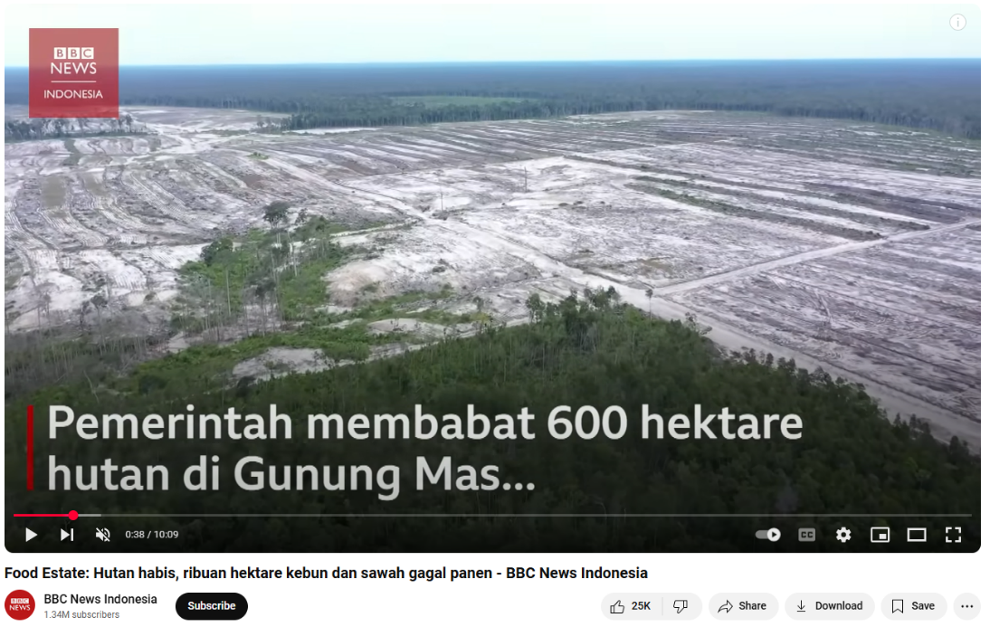

Picture 1 Deforestation of 600 hectares

The development of cassava food estate land in Gunung Mas only causes environmental damage because it sacrifices the forest area around Gunung Mas. The concept of food estate development is considered a failure because the government does not consider the land conditions and social conditions of the people around Gunung Mas. The food estate development project in Gunung Mas is managed by the Ministry of Defence but (*(118) Food Estate: Forests Depleted, Thousands of Hectares of Gardens and Rice Fields Fail to Harvest - BBC News Indonesia - YouTube*, n.d.).

The results of the netnography analysis, in addition to the content of the video, also examine how netizens behave in giving their responses through comment columns, emoticons, and like/dislike buttons. Supporting the study of netnography in this study is social network analysis using several analysis modules that show various results, namely:

*Table 1. Top 10 Fluctuations in Comment Emergence and Topic Formation 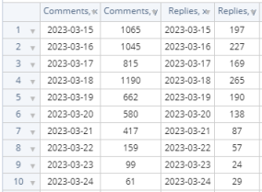*

**Topic Analysis**

The analysis uses a semantic analysis approach, which is to convert text data resulting from netizens' uploads into vector statistical data and then processed into Latent Topics, which are themes/abstracts of topics that have not been explored in depth, made based on categorization of word use (Akcayir et al., 2020).

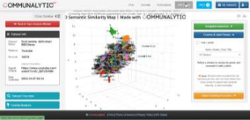

Figure 2 Semantic Similarity Analysis

Based on the topic relevance of the video conents, if you analyze using the hat module, 195 topics will appear from a total of 16,604 comments. 86 comments could not be made into a topic because the uploaded comments were too short to be less than 3 words.

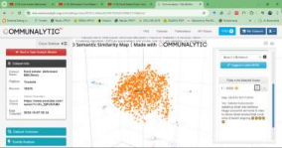

Figure 3 Top 1 Cluster

The 1000 comments appeared shortly after the video content titled Food Estate: Forests run out, thousands of hectares of gardens and rice fields failed to harvest - BBC News Indonesia uploaded by BBC News Indonesia. Based on the sample of comments that appeared, there is a tendency for netizens to spontaneously give their comments before watching the video, so it has the potential to cause discussions with various nuances. In the context of ethnography, spontaneous commenting behavior without first understanding the context of the message in its entirety, is influenced by the trend of information society that prioritizes speed over accuracy because the digital world has features for editing messages and uploading new messages as a form of updating messages that are less accurate.

**Sentiment Analysis**

Sentiment analysis is a response analysis based on the conversion of sentences into polarity numbers ranging from -1 to 1 based on the categorization of words in comment sentences in three categories, namely: neutral, positive, and negative. Netizens' responses are considered positive if the polarity value is >0.05, negative if the number is <0.05, and neutral if the number is somewhere between the two. The sentiment analysis used is the Communalytic application using the VADER and TextBlob formulas that are commonly used for English text analysis. The researcher found a discrepancy in the analysis of the instrument provided by Communalytic. VADER and TextBlob can also be used for Indonesian text analysis.

*Table 2 Results of Sentiment Analysis Using VADER and TextBlob 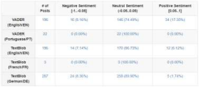*

Based on the data, the anomaly that appears is that it turns out that the VADER and TextBlob formulas can also be used to calculate sentence conversion into the polarity value of netizens' sentiment towards the content titled "*Food Estate: Forests are depleted, thousands of hectares of gardens and rice fields fail to harvest - BBC News Indonesia*". Researchers do not know the accuracy of the VADER and TextBlob calculation values in the analysis of the text of comments of Indonesian-speaking netizens on the BBC News Indonesia channel. The majority of Indonesian netizens responded neutrally to the implementation of a food estate in Gunung Mas, Central Kalimantan when viewed from the analysis of the text in the comment column of the BBC News Indonesia channel.

*Table 3 Recap of Positive Sentiment Content*

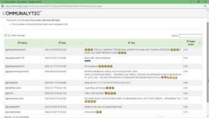

The researcher tried to analyze more deeply the results of VADER and TextBlob calculations related to the sentiment of netizens on food estate content in Gunung Mas. In the content with positive sentiments, there are a total of 34 positive comments, the majority of which are in Indonesian, but if examined more deeply based on ethnographic studies, the positive sentiment will not be in accordance with the responses that appear. The game of emoticons, uppercase, and satirical sentences with positive sentiments can actually give an idea The opposite emotions of netizens are negative sentiment towards the food estate project in Gunung Mas.

**Toxic Message Content Analysis**

Toxic message *analysis* aims to determine the level of danger of inflammatory messages in the conversations of netizens that are formed. The analysis of toxic message levels uses a machine learning module called Perspective by categorizing potentially dangerous sentences into 6 levels, namely:

1. Toxicity: rude, disrespectful, unwarranted
2. Severe Toxicity: hateful, aggressive, disrespectful
3. Identity Attack: offending an individual/group
4. Insult: an initial level insult before attacking an identity
5. Profanity (Dirty words): swearing
6. Threat: triggers heartache, physical injury, and individual/group violence

The results of the analysis using the Communalytic application in the toxic analysis module are comments that can be analyzed in the amount of 15,266 out of a total of 16,576 comment uploads. Comment uploads that are analyzed are uploads in the form of text, emoticons and texts in languages that use letters other than Latin cannot be analyzed.

**Conlusion**

This research mainly tries to see the response of communicators, namely netizens who commented on the BBC News Indonesia Youtube channel with the aim of being able to predict the potential for a more appropriate communication strategy in succeeding the food estate program in Gunung Mas, Central Kalimantan. Interestingly, at almost the same time, it turns out that one of the news media also makes content that is in line with BBC News content, namely Tempo through its Youtube channel Tempodotco. The video with the unique code daDzRLPXqrc also contains a description of the failure of the food estate program in Gunung Mas with its analysis study from different perspectives from different informant sources. Video

from Tempodotco entitled *Jokowi's Food Estate Deforestation: Damaged Forests, Floods in Village* Villages which was able to attract 1 million viewers and 5,018 comments that could not be analyzed until this research was completed.

**References**

*(118) Food Estate: Forests Depleted, Thousands Of Hectares Of Orchards And Paddy Fields Fail To Harvest - Bbc News Indonesia - Youtube*. (N.D.). Retrieved October 12, 2024, From

Akcayir, G., Chen, Z., Epp, C. D., Pandeliev, V., & Munteanu, C. (2020). *Two Case Studies Of Online Discussion Use In Computer Science Education*. 409–434.

*Analysis Of Sentiment And Communication Network Response Of Bpom Chairman Peny Lukito Case Of Acute Kidney Failure In Children In Youtube Account Kompas.Com | Eternal | Paradigm: Journal Of Social, Political, And Policy Issues*. (N.D.). Retrieved October 12, 2024, From Http://Jurnal.Upnyk.Ac.Id/Index.Php/Paradigma/Article/View/8980/Pdf

Ayun, Q., Kurniawan, S., Saputro, W. A., Program, M., Agribusiness, S., Science, F., & Technology, D. (2020). Development Of Agricultural Land Conversion In Agrarian Countries. *Vigor: Journal Of Tropical And Subtropical Agricultural Sciences*, *5*(2), 38–44. Https://Doi.Org/10.31002/Vigor.V5i2.3040

From Eco-Justice. *Litra: Journal Of Environmental Law, Spatial Planning, And Agrarian* Affairs, *2*(1), 41–62. Https://Doi.Org/10.23920/Litra.V2i1.1014

Hamdiah, A. N., Tjahjana, C., & Aliansyah, A. B. (2023). Analisis Ekonomi Politik : Studi Kasus Proyek Food Estate Menuju Ketahanan Pangan Di Indonesia Political Economy Analysis: A Case Study Of Food Estate Projects Towards Food Security In Indonesia. *Journal Of Political Voice*, *2*(2).

Hidayat, I. S., Wulandari, T. A., Adilla, M., & Pratama, R. (2024). Social Network Analysis Of The Success Of The "Don't Know?, Kasih No!" Campaign By Bank Central Asia. *Digital Transformation Technology*, *4*(1), 147–156.

Http://Web.Archive.Org/Web/20090601000000*/Http://Www.Alexa.Com/Topsites

Https://Doi.Org/10.4018/978-1-7998-3292-8.Ch017

Https://Doi.Org/10.47709/Digitech.V4i1.3761

Https://Journal.Aripafi.Or.Id/Index.Php/Jmpai/Article/View/74/118

Https://Katadata.Co.Id/Ekonopedia/Sejarah-Ekonomi/64dcb2c67f257/Riwayat-Food Estate-Carves-History-Of-Failure-From-Time-To-Time

Https://Support.Noduslabs.Com/Hc/En-Us/Articles/13237259670300-Social-Network Analysis-Of-Youtube-Comment-Replies-Bots-Or-Disillusioned-Citizens

Https://Www.Researchgate.Net/Publication/365628425

Https://Www.Youtube.Com/Watch?V=Zv_6jpudam4&T=63s

J Muntu, S. A., Pingkan Tangkudung, J. M., & H Lotulung, L. J. (N.D.). *Acta Diurna Communication Netnography Study On Instagram Social Media*.

Luthfyyah, A. A. M., Puspita, J. W., Maharani, L. S., & Kuncoroyakti, Y. A. (2021). Cyberbullying On Social Media: A Netnography Study On The Comments Of Rahmawati Kekeyi Putri Cantikka's Youtube Account. *Mediakom : Journal Of Communication Sciences*, *5*(2), 225–233. Https://Doi.Org/10.35760/Mkm.2021.V5i2.5290

Nahya Nurnafia, A., Dwi, H., Hadi, K., & Alamsyah, A. (2019). Detection Of Key Actors In Network Groups Formed Based On Indihome Product Interaction Patterns On Twitter Social Media. In *Journal Information Engineering And Educational Technology* (Vol. 03).

Rani, B., Wulandani, D., & Anggraini, W. (N.D.). *In The Village Of Satusaba*

Rasman, A., Sinta Theresia, E., & Fadel Aginda, And M. (2023). Analysis Of The Implementation Of The Food Estate Program As A Solution To Indonesia's Food Security. *Holistic: Journal Of Tropical Agriculture Sciences Research*, *1*(1), 36–68. Https://Doi.Org/10.61511/Hjtas.V

Rizkia Diffa Yuliantika, Imamulhadi, I., & Supraba Sekarwati. (2022). Juridical Analysis Of Food Estate Development Programs In Forest Areas Reviewed

Shajari, S., Agarwal, N., & Alassad, M. (N.D.). *Commenter Behavior Characterization On Youtube Channels*.

Siregar, G. N., Yogatama, B., Azahra, S. F., Ardianto, G., Sagita, V. A., Trilaksono, M., Abadi, D., Babarsari, Y. J., Bayan, T., & Sleman, Y. (2022). Framing News Of Soybean Scarcity In Kompas.Com. *Paradigm: Journal Of Social, Political, And Policy Issues*, *26*(2), 167–187. Https://Doi.Org/10.31315/Paradigma.V26i2.7455

*Social Network Analysis Of Youtube Comment Replies: Bots Or Disillusioned Citizens? – Nodus Labs Support Center*. (N.D.). Retrieved October 6, 2024, From

Sulianta, F. (N.D.). *Netnography Steps*.

*The History Of Food Estate, Making A History Of Failure From Time To Time - Katadata.Co.Id Economic History*. (N.D.). Retrieved October 12, 2024, From

Thelwall, M. (N.D.). *Social Media Analytics For Youtube Comments: Potential And Limitations 1*. Retrieved October 6, 2024, From

Trilaksono, M., Abadi, D., Sagita, V. A., Fariszy, R., Vegasari, R., Ratna, A., Communication, J. I., Development, U., Veteran, N., Tata, Y. J., & Art, K. (2024). Analysis Of Message Interpretation And Formation Of The Social Gram Of Gibran Rakabuming's 2024 First Speech For Vice President On The Kompastv Youtube Channel. *Paradigm: Journal Of Social, Political, And Policy Issues*, *28*(1), 195–222. Https://Doi.Org/10.31315/Paradigma.V28i1.11835

*View Of Netnography Study Of Ruqyah Syar'iyah Content On Ustadz Muhammad Faizar's Youtube Account*. (N.D.). Retrieved October 12, 2024, From