Comparative Analysis of S45C and JSC270C Materials in Gas Soft Nitriding and Isonite Processes on Surface Hardness, Compound Layer, Diffusion Layer, and Microstructure

Deviana Dewi Marshanda ¹, Imam Prabowo ¹, Thia Theresia ²
¹Universitas Pembangunan Nasional “Veteran” Yogyakarta, Indonesia
²PT. Parker Metal Treatment Indonesia
*Corresponding author : 116220020@student.upnyk.ac.id

Abstract
This research investigates the comparative effects of Gas Soft Nitriding (GSN) and Isonite surface treatment processes on two types of steel materials: S45C and JSC270C. Conducted at PT Parker Metal Treatment Indonesia, the study aims to analyze how these treatments influence surface hardness, compound layers, diffusion layers, and microstructure. A series of laboratory and field experiments were carried out, including micro-Vickers hardness testing and optical microscopy, to evaluate the mechanical enhancements and structural changes post-treatment. Results indicate that Gas Soft Nitriding generally produces a thicker compound layer and higher surface hardness compared to Isonite. However, the effectiveness of each process depends significantly on the material type and specific treatment parameters. These findings provide practical insight for industrial applications seeking to enhance wear resistance and surface performance of steel components through optimized thermochemical processes.

Keywords: Surface Treatment; Nitriding; Steel Hardness

Introduction
Mechanical properties are essential in determining how materials perform under external forces such as stress, torque, or pressure, especially in industrial applications where durability and reliability are crucial. With the continuous development of technology, improving material properties has become increasingly important. Among the most effective approaches are heat treatment and surface treatment, both of which modify the structure of metals to enhance their strength, hardness, and wear resistance.
PT Parker Metal Treatment Indonesia, a company specializing in these processes, regularly serves major clients with specific material requirements, including surface hardness. This study raises critical questions regarding how Gas Soft Nitriding (GSN) and Isonite treatments affect the mechanical and microstructural characteristics of two steel types, S45C and JSC270C. The core problem lies in determining which treatment method yields superior hardness, compound layers, diffusion layers, and microstructure in each material. Previous research has shown the significance of thermochemical treatments in industrial metallurgy, but comparative studies on these two methods remain limited.
This research is vital for optimizing industrial processes and selecting the most efficient surface treatment. The main objective is to analyze and compare the effects of GSN and Isonite on the selected steel types to identify the most effective method for improving surface performance.

Research Methods
This research was conducted through a series of practical field observations and laboratory-scale experiments at PT Parker Metal Treatment Indonesia, focusing on two thermochemical surface treatment processes: Gas Soft Nitriding (GSN) and Isonite. The experimental objects were two types of steel: S45C, a medium-carbon steel, and JSC270C, a low-carbon steel commonly used in automotive applications. The overall procedure began with specimen preparation, where raw materials were cut, cleaned using an alkaline degreasing tank, rinsed with compressed air, and dried. For the GSN process, specimens were subjected to a controlled gas-based treatment inside a furnace using ammonia as the nitrogen donor, with operating temperatures between 520°C and 570°C. Meanwhile, in the Isonite process, the specimens were immersed in a molten salt bath containing carbonate and cyanate compounds, typically operated at 570°C–590°C. Both processes aimed to form a compound layer at the surface and a diffusion layer beneath it through nitrogen diffusion. Pre-heating was applied to open the samples and improve energy efficiency, followed by appropriate cooling methods—air, water, or oil cooling—based on part geometry and customer requirements to prevent thermal distortion or dimensional changes.
After the surface treatment stage, samples underwent a sequence of material testing and characterization. Surface hardness was measured using the Micro Vickers Hardness Tester, which provided hardness gradients from the treated surface down to the untreated core. Microstructural evaluation was performed using optical microscopy to observe compound layers, diffusion depths, and phase transformations. The specimens were mounted, ground, polished, and chemically etched to reveal microstructural features. Photomicrographs were taken at different magnifications to compare the layer thicknesses and grain structures of both materials under each treatment. Comparative analysis was conducted between the two materials and the two treatment methods, evaluating parameters such as surface hardness, uniformity of diffusion, and porosity of the compound layer. A research flow diagram was developed to summarize the entire process from material selection, treatment execution, to final analysis, ensuring that each stage adhered to industrial standards and maintained experimental consistency. The integration of theoretical principles, such as Fe–Fe₃C phase diagrams and Time-Temperature-Transformation (TTT) diagrams, supported the interpretation of results and provided a framework for understanding the relationship between processing parameters and material behavior.

Result of Research and Discussion
The Gas Soft Nitriding (GSN) treatment resulted in a significant enhancement in the surface properties of both S45C and JSC270C steels. The maximum surface hardness achieved by S45C after GSN was approximately 720 HmV, while JSC270C reached a slightly lower but still substantial value of 665 HmV. These results suggest that the gas-phase diffusion process involved in GSN is highly effective in introducing nitrogen atoms into the steel surface, forming hard nitrides and solid solution zones which increase hardness. In terms of microstructural evolution, GSN produced a well-defined compound layer and diffusion layer in both materials. Visual and microscopic observations revealed that S45C exhibited a denser and slightly more porous compound layer, whereas JSC270C demonstrated a more uniform and fine-grained diffusion layer, particularly due to its lower carbon content which facilitates smoother nitrogen diffusion. The depth of the distribution layer, was greater in JSC270C, indicating enhanced diffusion kinetics in low-carbon steel matrices.
Compared to GSN, the Isonite treatment showed slightly lower surface hardness values. The surface hardness of S45C reached 551 HmV, and JSC270C achieved 493 HmV after undergoing Isonite treatment. Despite its lower hardness, Isonite offers other advantages, such as reduced thermal distortion and shorter processing time, which can be beneficial for components with tight dimensional tolerances. Microstructurally, the Isonite-treated specimens developed clear compound and diffusion layers. However, porosity was more noticeable in the S45C samples, especially in the compound layer. This due to the medium carbon content interacting with the nitrogen during the salt bath process, forming unstable compounds. In contrast, JSC270C samples showed a more consistent and less porous compound layer, aligning with its better diffusion behavior.
The depth of the diffusion layer in both materials and treatments. GSN generally yielded deeper and more gradual diffusion profiles compared to Isonite, particularly in JSC270C. The enhanced nitrogen penetration is attributed to the gaseous medium and longer exposure times, which facilitate more uniform and controlled diffusion without the harsh reactivity found in salt baths. Compound layers in S45C formed by both treatments were thicker and harder. In JSC270C, however, the layers were smoother, more stable, and better integrated into the substrate, offering balanced mechanical properties.
Microstructural observations using optical microscopy confirmed the presence of three distinct zones: the compound layer, the diffusion layer, and the core region. The compound layer in GSN-treated specimens was thinner but more uniform, while in Isonite-treated samples, it appeared denser yet porous. The presence of phases such as Fe₄N and Fe₂–₃N (in the compound layer) and diffused interstitial nitrogen in ferrite grains were inferred based on expected transformation mechanisms and are supported by the Fe–Fe₃C phase diagram and Time–Temperature–Transformation (TTT) diagrams. These diagrams provide theoretical validation that nitriding causes a surface hardening gradient, where hardness decreases from the surface towards the core.

Table 1 Surface Hardness Isonite with HmV

Table 2 Surface Hardness GSN with HmV

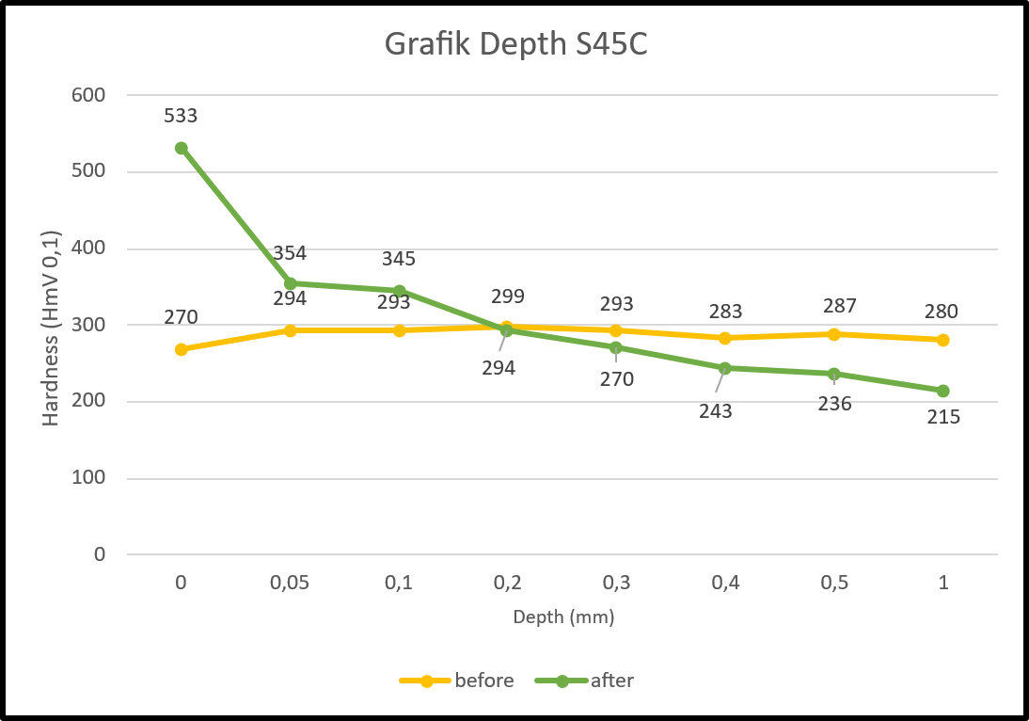
Figure 1 Grafik Depth of Distribution layer S45C Isonite

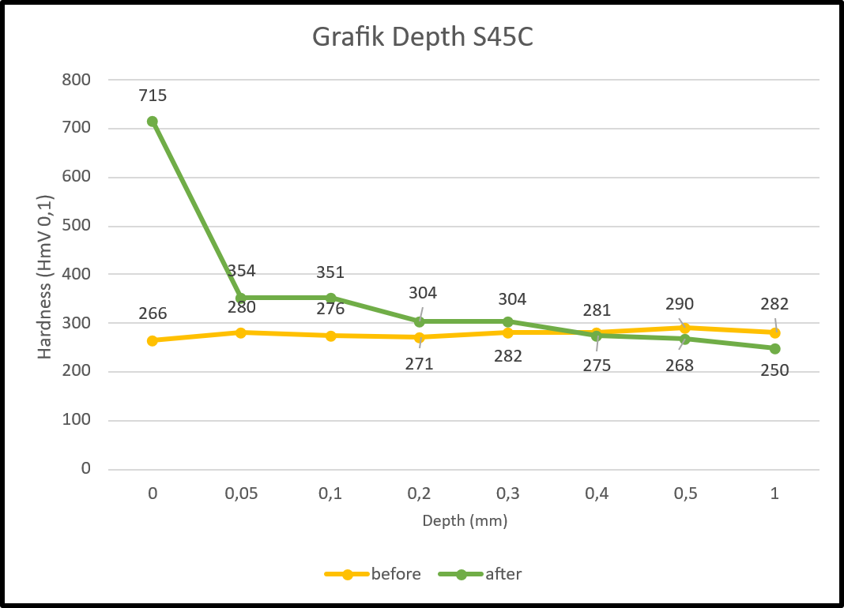
Figure 2 Grafik Depth of Distribution layer S45C GSN

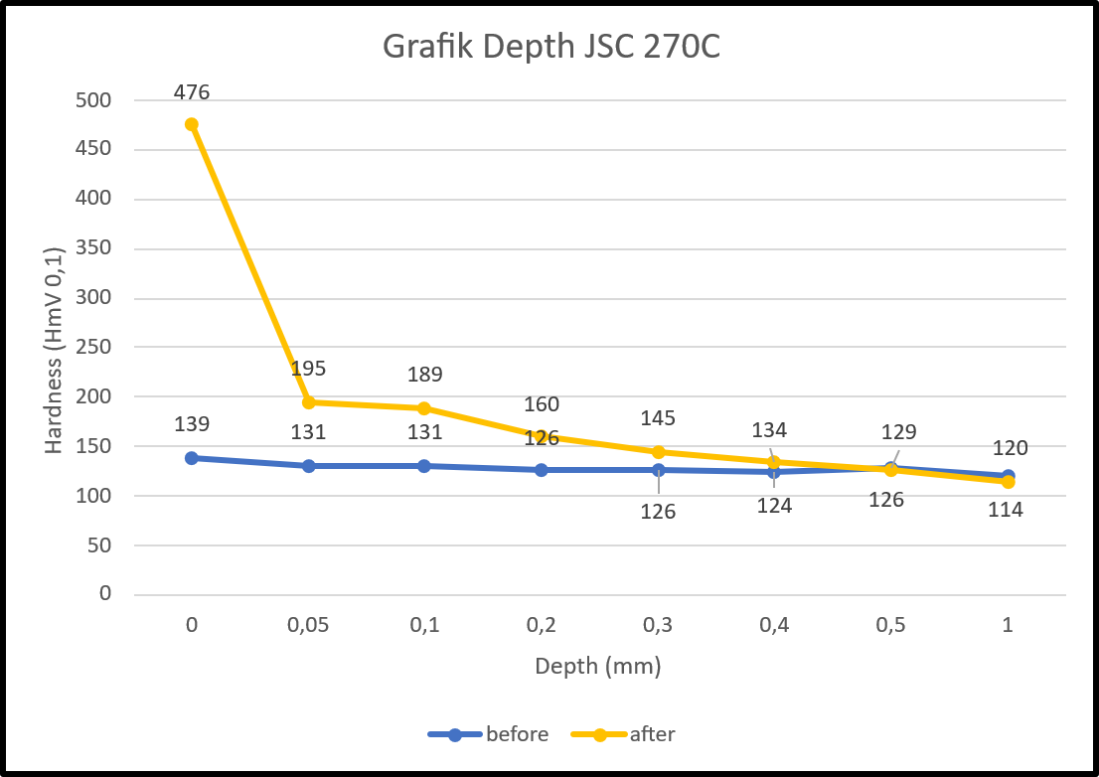
Figure 3 Grafik Depth of Distribution layer JSC270C Isonite

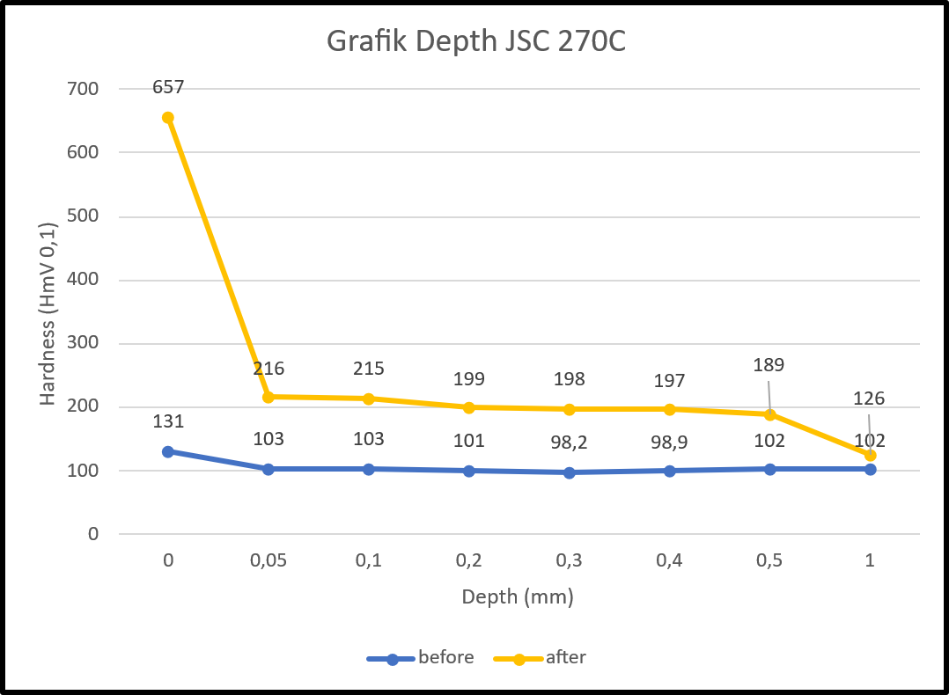
Figure 4 Grafik Depth of Distribution layer JSC270C GSN

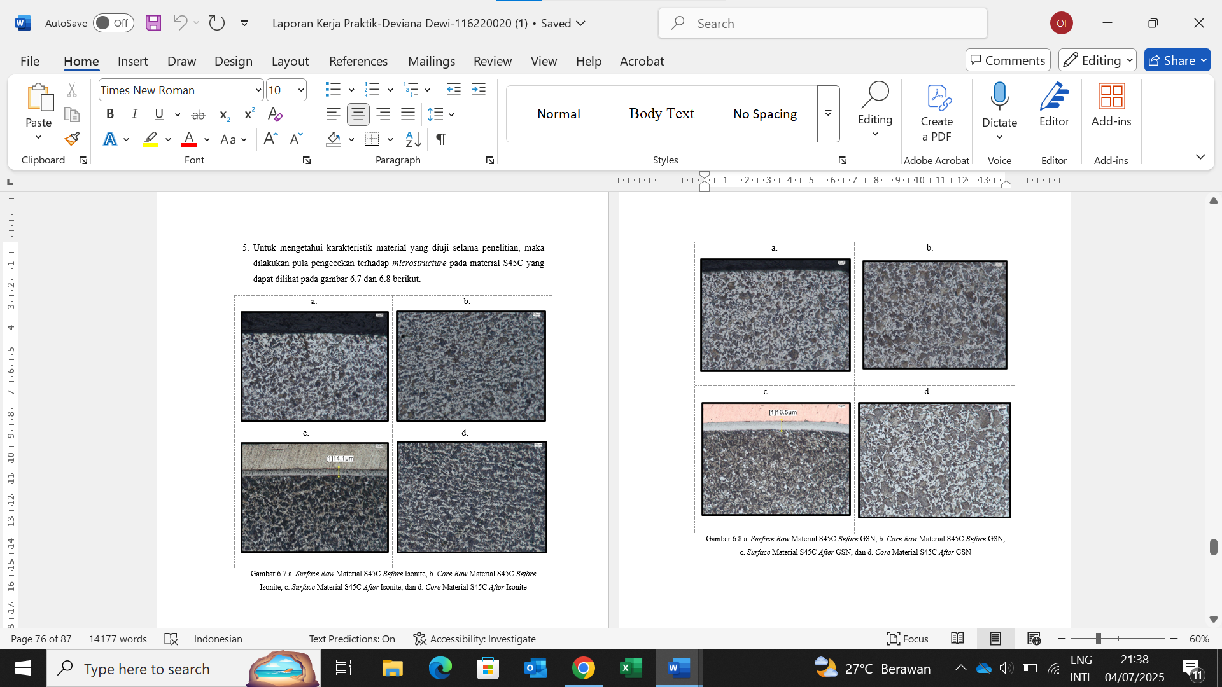
Figure 5 Picture of Surface and Core Raw Material S45C before and after Isonite

Figure 6 Picture of Surface and Core Raw Material S45C before and after Gas Soft Nitriding

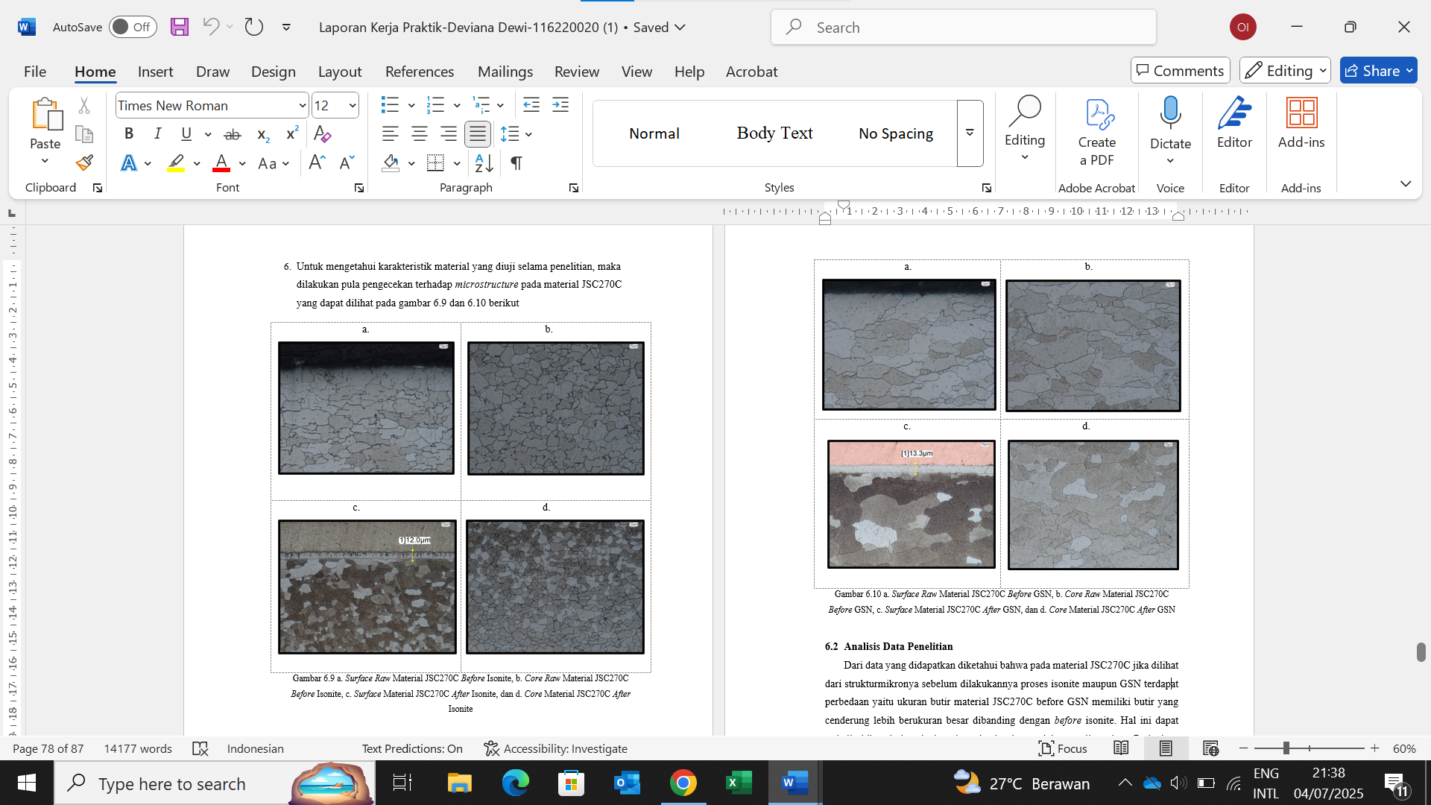
Figure 7 Picture of Surface and Core Raw Material JSC270C before and after Isonite

Figure 8 Picture of Surface and Core Raw Material JSC270C before and after Gas Soft Nitriding

Conclusion
Based on the results of this study, both Gas Soft Nitriding (GSN) and Isonite processes successfully enhanced the surface properties of S45C and JSC270C steel materials. However, GSN treatment generally produced higher surface hardness and thicker compound and diffusion layers compared to Isonite. These improvements contribute to better wear resistance and surface durability, making Isonite a more effective method for applications that require stronger surface performance. The impact of each treatment also varied depending on the type of steel, emphasizing the importance of selecting appropriate processes based on material characteristics and intended use. Overall, this research demonstrates the significance of surface treatment in optimizing the mechanical performance of industrial components.

Acknowledgements
The author would like to express sincere thanks to the production team at PT. Parker Metal Treatment Indonesia for their guidance and direction throughout this research. Special thanks are also extended to the management of PT. Parker Metal Treatment Indonesia for granting permission, which ensured the smooth execution of this study.

References

Agus Suprihanto. (2016). High Temperature Gas Nitriding Treatment Of Aisi 430 Using Low And High Purity Nitrogen Gas. Jurnal Teknik Mesin.
Aladin Eko Purkuncoro. (2020). Pengaruh Variasi Temperatur Pada Gas Nitriding Terhadap Surface Hardness Bahan Baja Aisi 4140. Juernal Teknik Mesin, Institut Teknologi Nasional Malang.
Yasuo Kurokawa, dkk. (1997). Soft Nitriding Steel. The Sumitomo Search.
Zaidao Yang. (2012). The Use of Nitriding to Enhance Wear Resistance of Cast Irons and 4140 Steel. Universitas of Windsor.

